Policies and Procedures

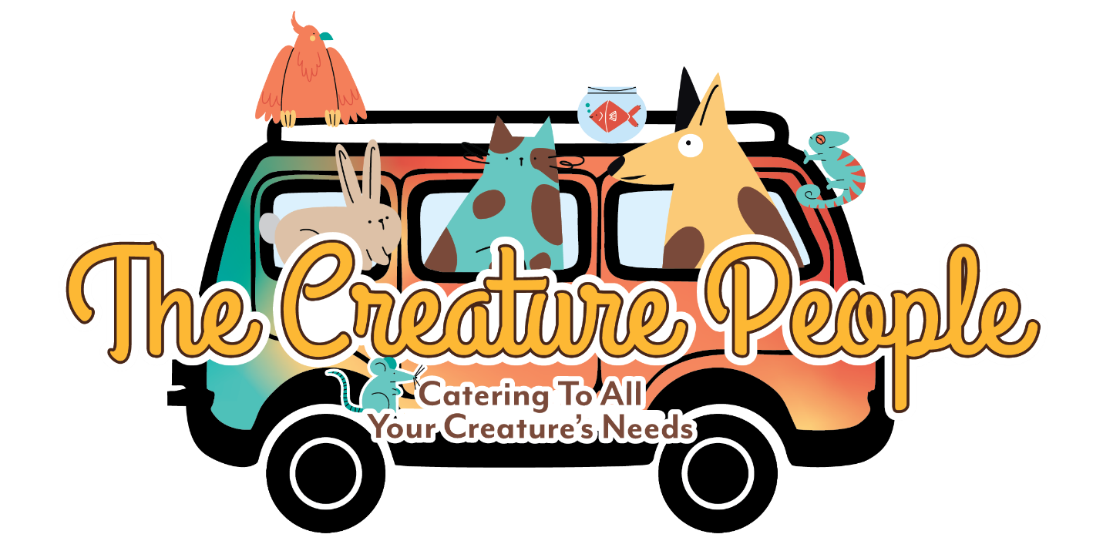

Client Agreement to Terms of Service
- Service providers reserve the right to cancel without refund during inclement weather, events of political unrest, local and national emergencies, and unforeseen illness. In lieu of a refund, funds will be allocated toward future service.
  - Instances include severe weather, national weather alerts regarding heat index, flash flooding, storms, and extreme temperatures.
  - Events of unrest include rioting, looting, burning, etc.
  - Local and national emergencies include power outages, water shut off, air quality alerts, etc.
- We have a ten-mile service radius, service outside of radius is subject to fuel upcharge.
- Client must provide proof of up-to-date vaccines and confirmation of a current parasite prevention.
  - Please note in terms of flea collars only seresto collars are accepted.
  - Grooming and outcall services require rabies vaccines only
  - Inhouse services requires all up to date vaccines.
- All outcall and in-house services require an emergency contact, as well as the name and address of current veterinarian.
- Pregnant females and females in heat will not be accepted.
- Keys and entry codes must be provided at the time of booking and no later than 48 hours prior to the time of booking. If not provided by this deadline, the booking is forfeited without a refund.
- The Creature People LLC does not job share any service.
- All intake forms and documents must be complete prior to any booking.
- Payment is required 24 hours prior to any booking.
- Prior to any overnight stay, all cats and dogs are required to undergo a one-on-one daycare trial and temperament testing for in-house services. Outcall services require a minimum of one trial walk or consultation in the pet owner’s home.

By signing below, you understand you are entering into a client agreement and that you agree to and understand the terms as they have been explained to you and listed here.

Sign and Date, Client (pet owner)

Sign and Date, Service Provider (authorized representative, The Creature People LLC)

